Ask Good Questions: A blog about teaching introductory statistics https://askgoodquestions.blog
Post #22: Four more exam questions https://askgoodquestions.blog/22-four-more-exam-questions

Feel free to use and/or modify the following exam questions for use with your students.

1. (6 pts) Researchers found that people who used candy cigarettes as children were more likely to become smokers as adults, compared to people who did not use candy cigarettes as children.

a) (1 pt) Identify the explanatory variable.

b) (1 pt) Identify the response variable.

c) (4 pts) When hearing about this study, a colleague of mine said: “But isn’t the smoking status of the person’s parents a confounding variable here?” Describe what it means for smoking status to be a confounding variable that provides an alternative to drawing a cause-and-effect explanation in this context.

2. (8 pts) The news website CNN.com has posted poll questions that people who view the website can respond to. The following results were posted on January 10, 2012:
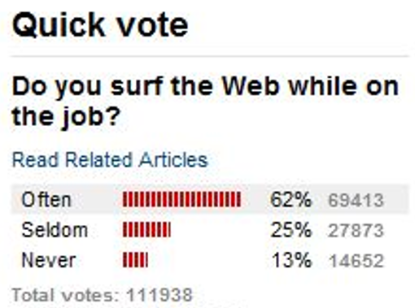

The margin-of-error, for 95% confidence, associated with this poll can be calculated to be ± .003, or ± 0.3%.

a) (1 pt) Are the percentages reported here (62%, 25%, 13%) parameters or statistics? Explain briefly.

b) (1 pt) Explain (using no more than ten words) why the margin-of-error is so small.

c) (3 pts) Would you be very confident that between 61.7% and 62.3% of all employed Americans surf the Web often while on the job? Circle YES or NO. Also explain your answer.

3. (12 pts) Researchers presented young children with a choice between two toy characters who were offering stickers. One character was described as mean, and the other was described as nice. The mean character offered two stickers, and the nice character offered one sticker. Researchers wanted to investigate whether infants would tend to select the nice character over the mean character, despite receiving fewer stickers. They found that 16 of the 20 children in the study selected the nice character.

a) (2 pts) Describe (in words) the null hypothesis in this study.

b) (3 pts) Suppose that you were to conduct a simulation analysis of this study to investigate whether the observed result provides strong evidence that children genuinely prefer the nice character with one sticker over the mean one with two stickers. Indicate what you would enter for the following three inputs: i) Probability of success, ii) Sample size, iii) Number of samples.

c) (1 pt) One of the following graphs was produced from a correct simulation analysis. The other two were produced from incorrect simulation analyses. Circle the correct one.

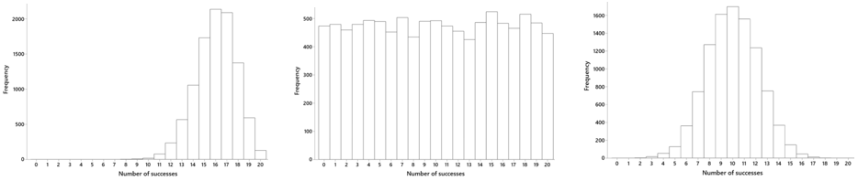

d) (1 pt) Based on the correct graph, which of the following is closest to the p-value of this test? (Circle your answer.) 5.00 .500 .050 .005

e) (2 pts) Write an interpretation of the p-value in the context of this study.

f) (3 pts) Summarize your conclusion from this research study and simulation analysis.

4. (16 pts) The Gallup organization released a report on October 20, 2014 that studied the daily lives and well-being of a random sample of American adults. The report compared survey responses between adults with children under age 18 living in the home and those without such children living in the home. The following table was provided in the report:

 | All adults | Adults with children under 18 in household | Adults with no children under 18 in household | Difference (percentage points)
% who smiled or laughed a lot on previous day | 81.2% | 84.1% | 79.6% | 4.5
Number who were surveyed | 131,159 | 36,043 | 95,116

a) (2 pts) Does this study involve random sampling, random assignment, both, or neither? Explain briefly.

b) (2 pts) State the appropriate null and alternative hypotheses (using appropriate symbols) for testing whether the two populations of adults differ with regard to the proportion who smiled or laughed a lot on the previous day.

c) (2 pts) The value of the test statistic turns out to be z = 18.5. Write a sentence interpreting the value of this z-test statistic. (This is not asking for a test decision or conclusion based on the z-test statistic.)

d) (2 pts) Would you reject the null hypothesis at the .01 significance level? Explain how your answer follows from the value of the z-test statistic.

e) (2 pts) A 99% confidence interval based on the sample data turns out to be (.039 .051). Interpret what this interval says in this context.

f) (2 pts) Is this confidence interval consistent with your test decision (from part d)? Explain how you know.

g) (2 pts) Give a very brief explanation for why this confidence interval is very narrow.

h) (2 pts) Suppose that someone reads about this study and says that having children in the household causes a very large increase in the likelihood of smiling or laughing a lot. Would you agree with this conclusion? Explain why or why not.

