Introduction to Bayesian Statistics
Allan Rossman, Cal Poly – San Luis Obispo
arossman@calpoly.edu
https://askgoodquestions.blog

presented for virtual Beyond AP Statistics workshop
August 17, 2020

During this session we will:
- Calculate “reverse” conditional probabilities as a derivation of Bayes’ Theorem;
- Explore how Bayes’ Theorem, along with the idea of subjective probability, forms the underpinning of a school of thought about conducting and interpreting results of statistical inference;
- Apply Bayesian inference to some examples;
- Describe how conclusions from Bayesian inference differ from conventional inference.

Zoom poll question: How familiar are you with Bayesian statistics?
- Not at all
- Have used Bayes’ Theorem to calculate “reverse” conditional probabilities, but have not heard of Bayesian inference
- Have used Bayes’ Theorem and have heard of Bayesian inference but do not know much about it
- Have applied Bayesian inference

Example 1: Diagnostic Tests
Suppose that when a person actually has a particular disease, a diagnostic test gives a positive result 98% of the time. Suppose that when a person does not have the disease, the test gives a negative result 92% of the time. Suppose that 1% of the population has the disease. (These percentages are called sensitivity, specificity, and prevalence, respectively.)

a) Zoom poll question: Without doing any calculations, which of the following do you suspect is closest to the percentage of people with positive tests who actually have the disease?
10% 30% 50% 70% 90%

To determine this updated/conditional probability of having the disease given a positive test result, imagine a hypothetical population of 10,000 people for whom these percentages hold exactly.

b) Use the give percentages to fill in the counts in the following table, in the order indicated:
 | Positive test result | Negative test result | Total number
Has disease | (3) | (4) | (1)
Does not have disease | (6) | (5) | (2)
Total number | (7) | (8) | 10,000

c) Of those who test positive, what proportion actually carry the disease? How does this compare to your prediction in a)? Explain why this probability is smaller than most people expect.

d) Has this probability (of carrying the disease) increased or decreased from when you had no partial information from the test result? By what factor has this probability increased or decreased?

- Bayes’ Theorem: $Pr\left(H|E\right)=\frac{Pr(E∩H)}{Pr(E)}=\frac{Pr(E|H)Pr(H)}{Pr\left(E|H\right)Pr\left(H\right)+Pr\left(E|H^{c}\right)Pr⁡(H^{c})}$
  - Pr(H) is called the prior probability of the hypothesis.
  - Pr(H|E) is called the posterior (updated) probability of the hypothesis given the evidence.
  - Pr(E|H) and Pr(E|H^{c}) are called the likelihoods of the evidence.

e) Fill in the following table to verify that Bayes’ Theorem produces the same calculations as above for the posterior probability of having the disease given a positive test result:
Hypothesis | Prior | Likelihood  (positive test result) | Prior × Likelihood | Posterior
Has disease
Does not have disease
Sum | 1.0 | XXX |  | 1.0

Zoom poll question: Do you think Bayes’ Theorem can be generalized to consider more than two hypotheses?
- No way, not even in your wildest dreams!
- Yes in principle, but we would need to learn a lot more math first!
- Sure, let’s do this!

- Bayes Theorem: Let A be any event and B₁, B₂, …, B_{k} form a partition of the sample space S. Then $Pr\left(B_{*}|A\right)=\frac{Pr(A|B_{*})Pr(B_{*})}{Pr(A)}=\frac{Pr(A|B_{*})Pr(B_{*})}{\sum_{i=1}^{k}{Pr(A|B_{i})Pr(B_{i}})}$.
  - A partition of a sample space is a set of events that are mutually exclusive and whose union comprises the entire sample space.
  - Notice that the denominator simply normalizes the numerators, ensures that the updated probabilities sum to one.
  - Proportionality version: $Pr\left(B_{*}|A\right)∝Pr(A|B_{*})×Pr(B_{*})$
    - Posterior $∝$ prior × likelihood

Example 2: Marbles
Suppose that we select one of six boxes at random by rolling a fair, six-sided die. Then we select a marble at random from the box that was selected. Each box contains 5 marbles, with color distributions of:
- Box 1: 0 green and 5 red marbles
- Box 2: 1 green and 4 red marbles
- Box 3: 2 green and 3 red marbles
- Box 4: 3 green and 2 red marbles
- Box 5: 4 green and 1 red marbles
- Box 6: 5 green and 0 red marbles
Suppose that the selected marble turns out to be green.

a) Given this evidence, which box is least likely to have been selected? What is the updated (posterior) probability for that box?

b) Given this evidence, which box is most likely to have been selected? Make a guess for the updated (posterior) probability for that box.

c) Fill in the following table to determine the posterior probabilities for each box:
Hypothesis  (which box) | Prior | Likelihood  (green marble) | Prior × Likelihood | Posterior
Box #1 (0 green, 5 red) | 1/6 | 0
Box #2 (1 green, 4 red) | 1/6 | 0.2
Box #3 (2 green, 3 red) | 1/6
Box #4 (3 green, 2 red) | 1/6
Box #5 (4 green, 1 red) | 1/6 | 0.8
Box #6 (5 green, 0 red) | 1/6 | 1.0
Sum | 1.0 | XXX | 0.5 | 1.0

Now suppose that we repeatedly draw a marble at random from the selected box, each time replacing the marble before we select the next marble. (But once we select a box, we always use that same box.) Suppose that we repeat this 17 times and find 14 green and 3 red marbles.

d) Given this evidence, make educated guesses for which box has the largest posterior probability and which has the smallest posterior probability.

e) Zoom poll: What probability distribution can we use to determine the likelihood function?
A. Beta B. Binomial C. Geometric D. Normal E. Uniform

f) Fill in the following table to determine the posterior probabilities for each box:
Hypothesis  (which box) | Prior | Likelihood  (14 green, 3 red marbles) | Prior × Likelihood | Posterior
Box #1 (0 green, 5 red) | 1/6
Box #2 (1 green, 4 red) | 1/6
Box #3 (2 green, 3 red) | 1/6
Box #4 (3 green, 2 red) | 1/6
Box #5 (4 green, 1 red) | 1/6
Box #6 (5 green, 0 red) | 1/6
Sum | 1.0 | XXX |  | 1.0

g) Which box has the largest posterior probability, and which has the smallest? Do these make sense? How were your educated guesses?

h) What is the posterior probability that the box selected contained more green than red marbles?

Now suppose that we have 101 boxes, with box #(i – 1) having i green and (101 – i) red marbles.

i) Zoom poll: How hard would it be to determine posterior probabilities, given the evidence/data of selecting 14 green and 3 red marbles, for this scenario?
A. Extremely difficult, would require much more sophisticated analyses
B. Very straightforward, as long as you have software to do the calculations

Hint: We would need to fill in a table such as:
Hypothesis | Prior | Likelihood | Prior × Likelihood | Posterior
Box #1 (0 green, 100 red)
Box #2 (1 green, 99 red)
…
Box #100 (99 green, 1 red)
Box #101 (100 green, 0 red)
Sum | 1.0 | XXX |  | 1.0

j) Use software (R or Excel) to determine the posterior probabilities. Also produce a graph of the posterior probabilities. Describe the distribution of these posterior probabilities.

k) Which box has the highest posterior probability, and what is that probability? What is the proportion of green marbles in that box? Explain why this makes sense.

l) What is the posterior probability that the box selected contained more green than red marbles?

Why did we waste our time with such a boring, generic example? The big payoff will come after the following digression.

Example 3: Subjective Probability
- The frequentist interpretation of probability is the long-run proportion of times that the event would occur, if the random process were repeated a very large number of times.
- The subjectivist interpretation of probability is an individual’s degree/measure of belief about how likely an event is to occur (or have to occurred) or a proposition is to be true.
  - Different people can have different probabilities for the same event.
  - Subjective probabilities are coherent if they satisfy rules of probability.

Report your (subjective) probability for each of the following events:

a) that the United States will have a woman as president within the next decade

b) that the Philadelphia Phillies will win their next game

c) that James Buchanon was the 14th president of the United States

d) that the Philadelphia Phillies won their first game of this season

e) that more than 25% of U.S. adults have a tattoo

f) that the average body temperature of a healthy adult is between 98.5 and 98.7 degrees F

g) What do the events in a) and b) have in common?

h) What do the events in c) and d) have in common?

i) What do the events in e) and f) have in common?

Are you ready? Here it comes: This is where the Bayesian magic happens and a whole new world opens up!

A Bayesian analysis:
- regards the parameter as a random variable (not as a fixed by unknown value),
- assigns a (subjective) prior probability distribution to the parameter,
- conditions on the observed data by applying Bayes’ Theorem to produce a posterior probability distribution for the parameter,
- calculates the posterior probability that the parameter falls in some interval of interest, including:
  - Posterior probability of alternative hypothesis
  - 95% posterior probability (credible) interval

Example 4: Blindsight
A patient suffered brain damage that caused a loss of vision on the left side of her visual field. A researcher showed two cards to this patient. Each card showed a simple line drawing of a house. However, one of the drawings showed flames coming out of the left side of the house. The researcher shuffled the two cards, placed them down on a table with one card above the other, and asked the patient which house she would rather live in. The patient replied that this was a silly question because “they are the same.” The researcher asked her to choose anyway. The cards were shuffled and placed on the table a total of 17 times. The patient chose the non-burning house in 14 of those 17 showings. The researcher investigated whether these data provide strong evidence that this patient has a condition known as “blindsight,” meaning that she responds to information from the blind part of her visual field even though she cannot “see” those stimuli. (This study is described here: https://www.nature.com/articles/336766a0.)

a) Describe the parameter of interest in this study. Also use a symbol to represent this parameter.

Let’s start with a prior distribution that says that this parameter is equally likely to be any value between 0 and 1 (inclusive) in multiples of .01.

b) Determine the posterior distribution of the parameter, conditional on the evidence/data that the patient selected the non-burning house for 14 of 17 showings. (Hint: We’ve already done this; this is why we spent so much time on that boring, generic example about marbles!)

c) Determine the posterior probability that the parameter value exceeds one-half.

Much more common is to use a continuous prior probability distribution for the parameter.
- Bayes’ Theorem for continuous random variables: $p\left(θ | x\right)=\frac{p\left(θ\right)f(x|θ)}{\int_{-∞}^{∞}{p\left(θ\right)f(x|θ)dθ}}$,
  - Notice that $p\left(θ | x\right)∝p\left(θ\right)f\left(x | θ\right)$
    - Posterior $∝$ prior × likelihood
  - Likelihood f(x|θ) could be discrete (e.g. binomial) or continuous (e.g. normal)

For inference about the underlying success probability in a binomial distribution, it is convenient to use a family of continuous distributions known as Beta distributions.

- Beta distribution: probability density function $p(θ)∝θ^{α-1}{\left(1-θ\right)}^{β-1}$ for 0 < θ < 1.
  - Mean α / (α + β)
  - Variance $\frac{αβ}{{\left(α+β\right)}^{2}\left(α+β+1\right)}$
  - Uniform distribution: Beta(1,1)
- If X | θ ~ Binomial(n, θ) and θ ~ Beta(α, β), then θ | x ~ Beta(α + x, β + n – x)
- When the prior and posterior distribution belong to the same family, that family is called a conjugate prior distribution for the likelihood.
  - So, the beta distribution is a conjugate prior for the binomial distribution.

The Beta distribution allows for very shapes:
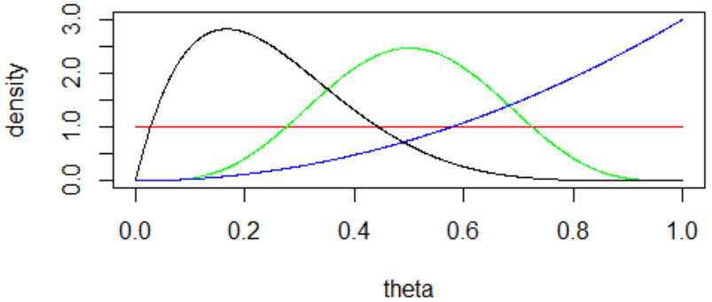

d) Now let’s use a continuous uniform distribution on the interval (0,1) as the prior distribution for the parameter. Determine the posterior distribution of the parameter, conditional on the data that 17 trials resulted in 14 successes. Use software to graph the prior and posterior distributions on the same axis. Describe how they compare.

e) Determine the posterior probability that the parameter exceeds one-half. (Software is crucial for this calculation.) Summarize what this probability reveals.

- A Bayesian analysis allows for determining a probability that the null (or alternative) hypothesis is true!

f) Calculate the posterior mean of the parameter. Where does this fall in comparison to the prior mean and sample proportion? Explain why this makes sense.

- The posterior mean is a weighted average of the prior mean and the sample proportion.
  - Posterior mean = $\left(\frac{α+β}{α+β+n}\right)$×prior mean + $\left(\frac{n}{α+β+n}\right)$×sample proportion

g) Determine the posterior SD of θ. How does it compare to the prior SD? Explain why this makes sense.

- The posterior SD generally decreases as the sample size increases.

h) Now consider a classical, frequentist analysis of these data. Calculate the (exact) p-value for a significance test of whether the sample data provides strong evidence that the patient tends to select the non-burning house. Interpret what this p-value means, and summarize your conclusion.

- Bayesian analysis conditions only on the observed data.
  - As opposed to classical p-value, which also considers outcomes that did not occur (“more extreme”)

Example 5: Kissing
Most people are right-handed, and the right eye is dominant for most people. Developmental biologists have suggested that late-stage human embryos tend to turn their heads to the right. In a study reported in Nature (2003), German bio-psychologist Onur Güntürkün conjectured that this tendency to turn to the right manifests itself in other ways as well, so he studied kissing couples to see which side they tended to lean their heads while kissing. He and his researchers observed kissing couples in public places such as airports, train stations, beaches, and parks. They were careful not to include couples who were holding objects such as luggage that might have affected which direction they turned. They observed 124 kissing couples, 80 of whom leaned their heads to the right.

a) What are the observational units in this study? What is the variable? What kind of variable is this?

b) What proportion of couples in the sample leaned their heads to the right?

c) Describe the parameter of interest.

First start with a uniform prior distribution for the parameter.

d) Determine the posterior distribution. Also graph the prior and posterior distributions on the same axis. Comment on how they compare.

e) Determine the posterior mean and posterior SD of the parameter.

f) Determine the 2.5th and 97.5th percentiles of the posterior distribution, and report the resulting interval.

g) Determine a (classical) 95% confidence interval for the parameter.

h) Comment on how these two intervals, and their interpretations, compare.

- A 95% posterior credible interval says that the parameter has a 95% chance/probability of falling within the interval.
  - As opposed to a classical confidence interval, for which probability pertains only to repeated application of the procedure, not to the specific interval

The two graphs below show different prior/posterior distributions from this kissing study.

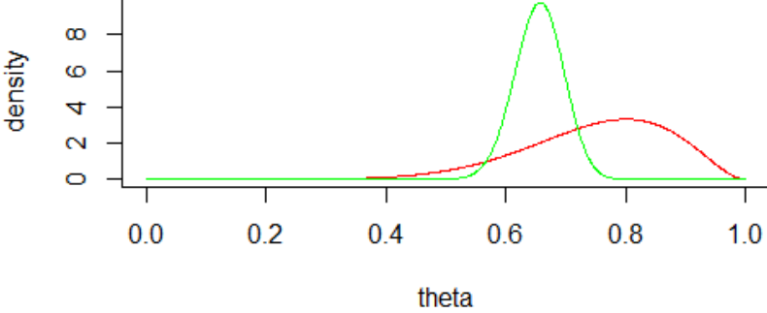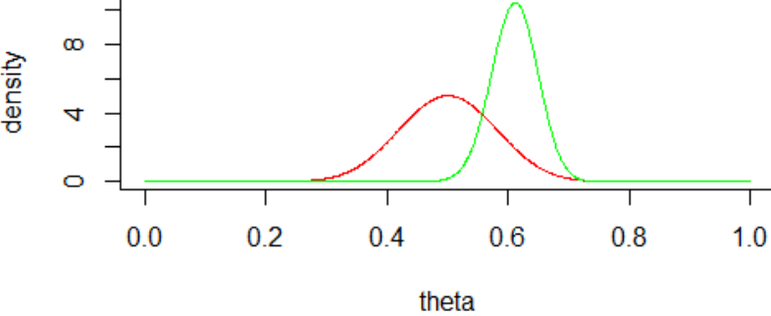

i) Describe how the two prior distributions compare (shape, center, variability).

j) Describe how the two posterior distributions compare.

k) Determine 95% posterior credible intervals for the parameter, based on each of tehse prior distributions.

l) Comment on how these two intervals compare.

- The choice of prior distribution has less and less impact as the sample size increases.

This Bayesian approach can be applied similarly to other parameters: population mean, difference in population proportions/mean, regression coefficients, etc.
- The underlying math gets harder, but software can handle it with ease.
  - Markov Chain Monte Carlo (MCMC) method is especially helpful.

